A444 (2020), Seven days tour, connecting to Kul-Tas-Kul flights (Thu-Wed flights)

Tour highlights:
- Visiting Hasti Imam Complex in Tashkent with first Quran in the world – Othman Quran
- Visiting Al Bukhary memorial complex in Samarkand
- Visiting marvelous “Registan” square in Samarkand
- Dinner is at traditional Uzbek house in Samarkand
- Traditional cultural show “Uzbek Bride” (15 and more pax)
- Pottery master class (15 and more pax)
- Traditional bread backing master class (15 and more pax)
- Shish kebabs master class (15 and more pax)
- Bukhara pilaw master class during the dinner in Bukhara
- A4 size photo in frame to every family with your company logo.
- Coffee and tea at bus stops during long journeys (15 and more pax)

Day 1, Thu: Tashkent – Samarkand B/L/D
Arrival Tashkent airport at 03:25 am. Take packed breakfast and transfer to Samarkand (350 km, 4.5 hrs drive). Arrival, early lunch and check in to the hotel (after 12:00), time for rest. Late afternoon visit see memorial complex of Al Bukhary. Al Bukhary was an Islamic scholar, who authored the hadith collection known as Sahih al-Bukhari, regarded by Sunni Muslims as one of the most authentic Hadith collections. He also wrote other books such as Al-Adab al-Mufrad. Dinner and overnight.

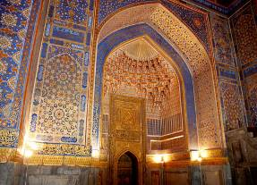
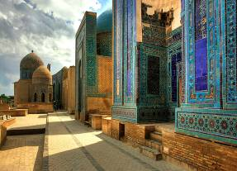

Day 2, Fri: Samarkand B/L/D
Samarkand is situated in the valley of the river Zerafshan. It is the second largest city of Uzbekistan and is of the same age as the city of Babylon or Rome. Today you will visit its most outstanding sights such as Registan square, Shakhi-Zindeh, Mausoleum Guri Emir and Bibi Khanum Mosque. Registan Square, a complex of three fascinating Madrasahs dating back to 15-17th centuries, is the main highlight of Samarkand that no person can stop admiring its beauty and majesty. Architectural complex of Shakhi-Zindeh represents a big collection of mausoleums dating back to 11th-15 centuries being a part of a UNESCO World Heritage Site. Bibi Khanum Mosque was built in honor of favorite Tamerlane’s wife, after his successful campaign in India. Overnight is at the hotel.
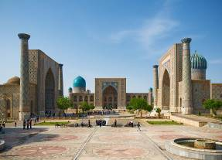
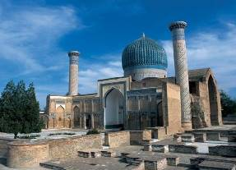

Day 3, Sat: Samarkand – Gijduvan – Bukhara B/L/D
After breakfast we will start our way to Bukhara. On the way, we will stop over at Gijduvan village to visit famous private pottery workshop. Gijduvan ceramics school has its deep roots. The skills have been passed from father to son from generation to generation. Today Gizhduvan is home for the sixth generation of potters from Narzullayevs family which glorified Gijduvan school ceramics all over the world. Gijduvan School of ceramics is distinguished by a geometric pattern. Green and blue colors prevail in decoration of products. Afterwards we continue driving to Bukhara. Night is in a hotel.
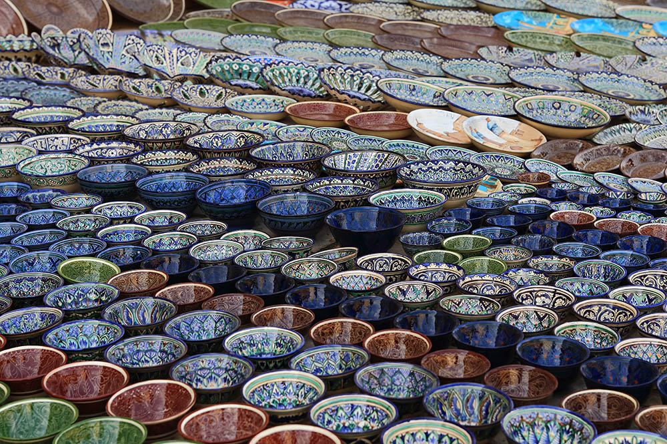
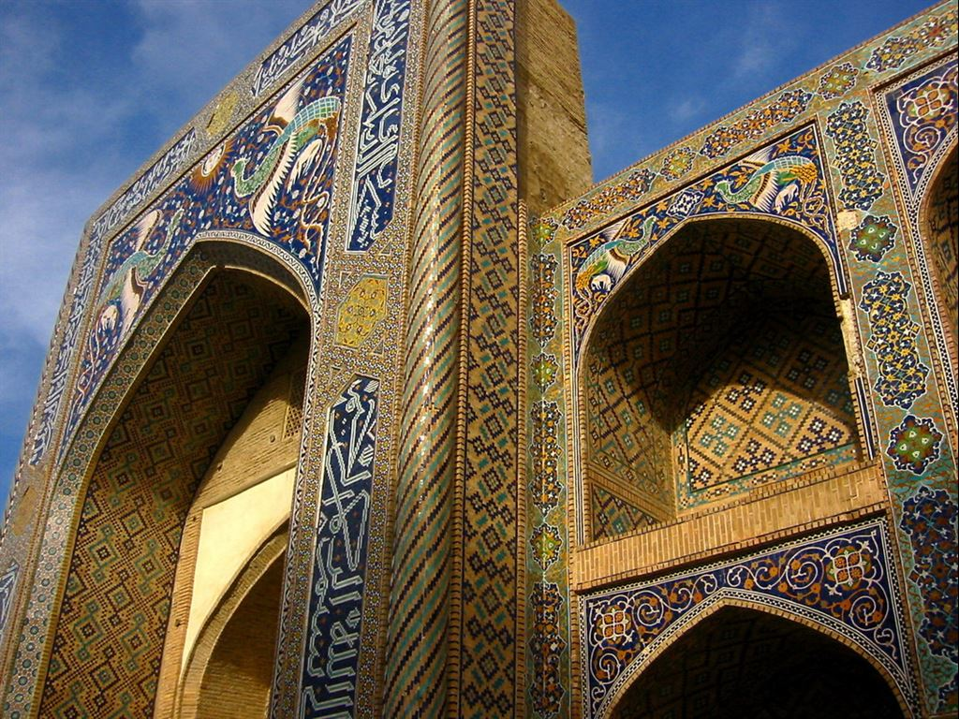

Day 4, Sun: Bukhara B/L/D
Today you will have a full day of sightseeing tour in the fascinating city of Bukhara. At first you will visit the most ancient citadel in Bukhara dating back to the 4th century named Citadel Ark which served as a palace for several dynasties of Bukhara Empire. Then you will see Samanids mausoleum, a real masterpiece of architecture of 9th -10th century. Then the tour continues to Chashma Ayub, meaning Job's well and Bolo-Hauz mosque, known also as the mosque of forty columns built in honor of Bukhara governor Abu-Fayud Khan. Then you have a chance to walk along the shopping domes and visit one of the most famous madrasahs of Bukhara called Nodir Divan Begi which is also a part of Lyabi House Ensemble, famous central sightseeing of Bukhara. Night is in a hotel.
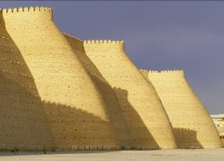
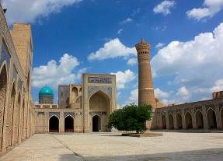

Day 5, Mon: Bukhara – Tashkent (flight) B/L/D
Morning flight to Tashkent (aprox 08:50-09:50). Today you will visit Independence square which is the main square of the country, erected as a symbol of victory over fascism in World War II. Then you will have a chance to walk along the local Broadway, a walking street between independence square and Amir Timur square. Further you can take a ride in famous Tashkent metro, among the most beautiful subways in the world. First line was opened in 1977. Then you will visit the old part of the city which includes: Chorsu Bazaar, Kukaldash Madrasah and Hast Imam complex that consists of several madrasahs, mosques and mausoleum. The highlight of its exhibits is the Othman Quran which is the world’s oldest Quran copy dating back to 8th c. Quran belonged to Othman Ibn Affan, the Third Caliph (of the four righteous Caliphs who succeeded the prophet Muhammad). Othman was killed by non-muslims in 8th century. His blood spred over the Quran that you still can see on its pages. Night is in a hotel.
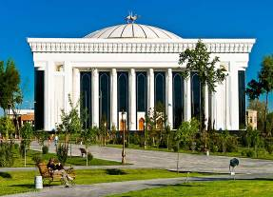
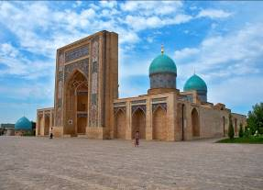

Day 6, Tue: Tashkent – Chimgan Mountains – Tashkent
In the morning you will transfer to Chimgan Mountains. Upon arrival you will have a chair lift to reach the top to see Beldersay peak 30 min one-way. Here you will have some free time for walking around, enjoying the nature. On the way back you will stop over at Charvak lakeside beach for free time and own water activities (as per season). Charvak is an artificial lake, a popular resort in Tashkent region and thousands of holiday makers from all over Uzbekistan and neighboring countries visit the reservoir. In the end of the day is return to Tashkent. Night is in a hotel.

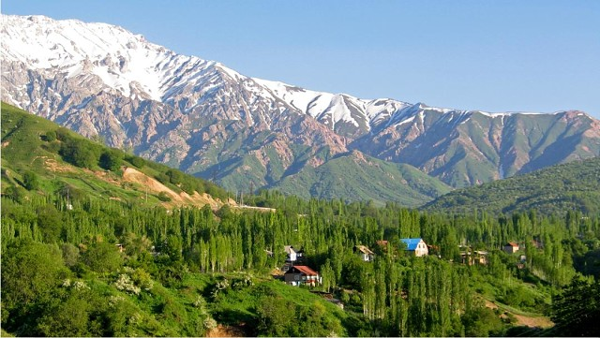
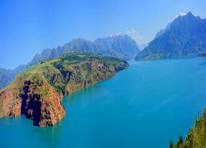

Day 7, Wed: Tashkent – Flight
Transfer to airport and flight home.

Travel Map:
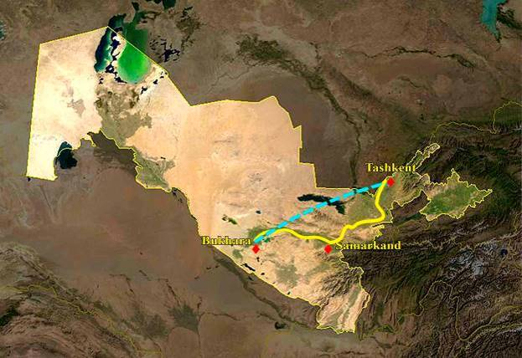

Type of transport:
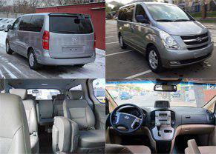
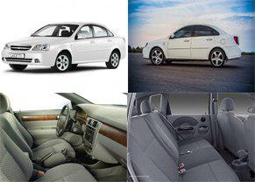

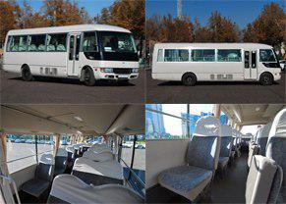
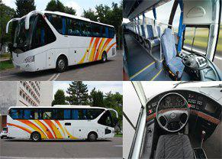

Pricing 01.03.20-15.11.20
Persons | Price per person in USD
Persons | Option A | Option B
2 | 790 | 925
4 | 620 | 760
6 | 545 | 680
8 | 560 | 695
10 | 525 | 660
10+1 Foc | 550 | 705
15+1 Foc | 520 | 665
20+1 Foc | 480 | 620
25+1 Foc | 460 | 595
30+1 Foc | 445 | 580
35+1 Foc | 435 | 565
40+1 Foc | 425 | 555
Single Supplement | 80 | 225
Bullet Train  Tashkent-Samarkand | 25 – economy  45 – business

Cities | Nights | Option A | Option B
Tashkent | Two | Tourist Inn 3* | Rakat Plaza 4*
Bukhara | Two | Porso 3* | Omar Khaym 4*
Samarkand | Two | Ideal 3* | Diyora 4*

Price includes:
- Accommodation at mentioned hotels on double share basis
- Transportation per program in comfortable a/c transport with professional drivers
  - 2 pax – Sedan (Lacetti Chevrolet)
  - 4-8 pax – Minivan (Grand Starex, Istana)
  - 10-14 pax – Midibus (Mitsubishi Rosa, Sprinter)
  - 15 and more pax – Big Bus (Yutong, Higer)
- Breakfasts at the hotels
- All lunches and dinners per program
- Daily two bottles of 0.5l water per person
- All master classes and show programs per program (groups of 15 pax and more)
- Escort English speaking guide for entire tour (Bahasa speaking is as per request)
- Entrance fees to mentioned sights per program (excluding photo and video charges at sights)
Price does not include:
- Visa consular fees and processing expenses
- Photo and video charges at sights
- International air tickets to / out of Tashkent
- Domestic flight: Tashkent – Bukhara
- Bullet train tickets
- Travel Insurance
- Extras, not indicated in inclusions

PS:
- Pricing valid for contracted partners only for mentioned dates
- If mentioned hotels are overbooked or not available, we will give appropriate alternative.
- If there is no free seats in bullet train, we will replace by normal train.

Payment:
- Tour payment should be made not less than 40 days prior to tourist group arrival to our bank account as per sent invoice.
- The rooming list should be finalized 30 days before arrival.

Cancellation fees:
- No charges up to 45 calendar days up to tour starting date
- 50% of full package price up to 14 calendar days up to tour starting date
- 100% of full package price – 7 or less working days up to tour starting date or no show.

